Otter Class English Overview
Week | 1 | 2 | 3 | 4 | 5 | 6 | 7 | 8 | 9 | 10 | 11 | 12
Autumn | The Green Ship by Quentin Blake  ▪  - Poetry  - ▪ Persuasion piece  - ▪ Narrative – innovated version of the story  Book Making |  |  |  |  |  | African Tales, a Barefoot Collection by Gcina Mhlophe,  - Information booklet  - Letter of advice  - Newspaper article
Spring | 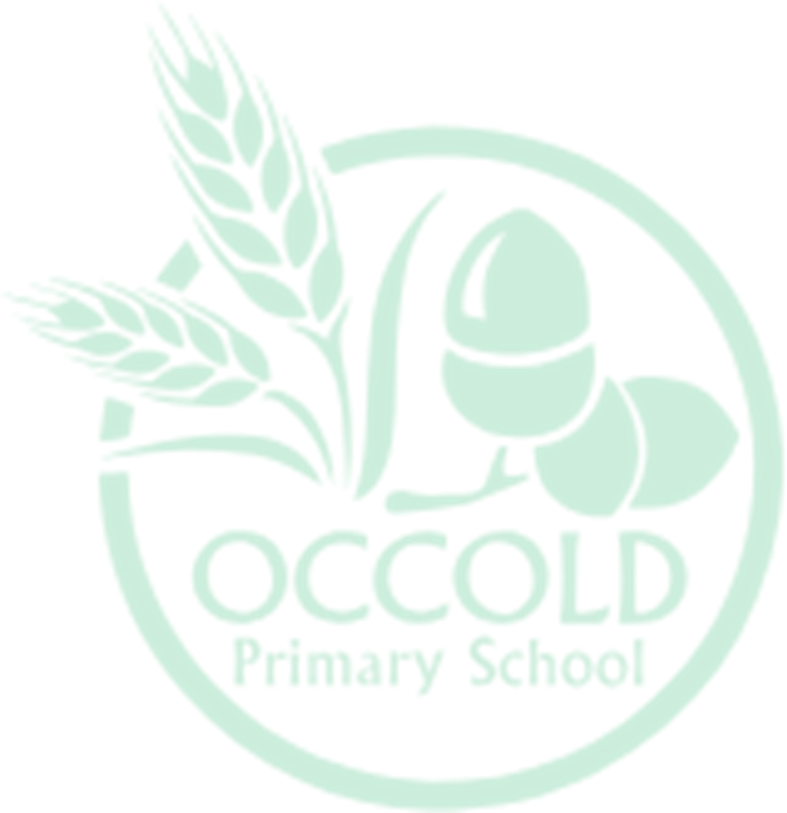  Firebird, Retold by Saviour Pirotta  - ▪ Poetry - Book Making▪  - Report writing ▪  - Writing a diary entry in role |  |  |  |  |  | Arthur and the Golden Rope by Joe Todd-Stanton•  - Letter Writing •  - Non-Chronological Report •  - • Comic Book Writing – Book Making
Summer | Lob by Linda Newbery,  - Instructions ••  - Persuasive and Explanatory Presentation •  - Persuasive Speech • |  |  |  |  |  | The Little Island written by Smriti Prasadam-Halls  - Letter writing  - Instructions  - Story Writing – Book Making

