Occold Primary
School

Handwriting Policy



Intent
Handwriting is a fundamental skill that underpins the quality, fluency and quantity of written work across the curriculum. By the end of Key Stage 2, pupils should be able to produce fluent, legible, joined handwriting and to select appropriate forms of handwriting for different purposes. Our intention is to make handwriting an automatic skill so that it does not create cognitive load, freeing up children to explore creativity, composition and higher-order thinking.
Aims
- To build fine and gross motor skills that support early pencil grip, posture and letter formation.
- To develop a clear, consistent style of handwriting that becomes increasingly fluent and automatic, enabling pupils to write at speed without hindering the quality of their ideas.
- To provide systematic, progressive teaching of handwriting, including modelling and daily practice, so that pupils can form and join letters accurately and confidently.
- To establish and maintain high expectations for the presentation of written work across all subjects.
- For pupils to understand, by the end of Year 6, the importance of neat presentation and the ability to use different letterforms (cursive, print, capitals) effectively to communicate meaning.

Implementation
At XXXX Primary School we use Letter-join’s online handwriting resource and progression as the foundation of our handwriting policy. This scheme fully meets the requirements of the National Curriculum while supporting pupils to develop fluency, stamina and automaticity in their writing.
Letter-join provides high-quality, systematic resources that give staff clear guidance and a consistent progression from the early development of motor skills in Reception through to fluent, joined handwriting by the end of Key Stage 2. Daily practice materials, modelling tools and interactive activities enable teachers to deliver handwriting lessons with confidence and ensure continuity across year groups.
Pupils benefit from structured opportunities to revisit and consolidate previous learning, while gradually increasing speed and fluency so that handwriting does not become a barrier to creativity or composition. The programme also links closely with phonics, spelling and grammar, reinforcing key literacy skills.
Because Letter-join is accessible both in school and at home, children and families are able to practise and apply the letter and number formations taught in class, supporting strong home–school partnership and consistency of approach.

Aligned with Writing Framework 2025

Teach handwriting and spelling (transcription) from Reception | Teaching handwriting should begin in the Reception year, to help these skills become automatic and free up working memory for composition.
Handwriting must be explicit, systematic, and cumulative | Handwriting should not be incidental or piecemeal-it needs to be taught in a careful progression, with modelling, clear demonstration, and daily practice.
Handle the physical demands of handwriting | Handwriting is physically demanding (fine motor control, posture, grip). It advises supporting pupils with the physical aspects (posture, pencil grip, choice of writing implements, adaptations for left-handers)
Fluency is essential to reduce cognitive load | Slow or laboured handwriting imposes cognitive load, making it harder for pupils to think about what they want to say. Fluency in handwriting helps free working memory for content, revision, editing, etc.
Do not rush into joining / cursive writing | Joined writing should only be introduced when pupils can consistently form printed (unjoined) letters correctly and fluently. It also states that “lead-in strokes” (pre-cursive print) are not required straight from the start in Reception.
Handwriting is part of the “transcription” strand in the Simple View of Writing | Writing is conceived as having two main components: transcription (spelling + handwriting) and composition (ideas, grammar, structure). The framework emphasizes that without competent transcription, writing composition will always struggle.
Use letter “families” to support systematic teaching | Grouping letters with similar formation patterns (“families”) helps structure learning.
Demonstration and modelling by teachers is crucial | Teachers must model good posture, pencil grip, letter formation. Pupils benefit from seeing the ‘thinking aloud’ in writing and how to form letters correctly.
Daily, distributed practice, consolidation & revision | Handwriting practice should be regular (ideally daily), cumulative, and provide opportunities to practice past letters rather than only new ones. Also, pupils should revisit letters they don’t yet form correctly before moving on.
Support for pupils needing extra help | Early identification of children who struggle with handwriting is important, and additional scaffolding, time, and practice should be provided.
Handwriting instruction should be separate from phonics instruction | Handwriting (letter formation) should not be subsumed entirely within phonics lessons it needs its own dedicated time and explicit teaching.

Expectations
To ensure consistency throughout the school, all teaching staff are encouraged to model the cursive style in all their handwriting, including whiteboards, displays or when giving feedback in pupils’ books. Wherever possible, worksheets should also be in cursive script and used minimally to encourage children’s writing.
Pupils should experience coherence and continuity in the learning and teaching of handwriting across all school years and be encouraged to take pride in the presentation of their work. Our objective is to help pupils enjoy learning and developing their handwriting with a sense of achievement and pride.

Pens and pencils
Children will start handwriting using a soft pencil. When fine motor skills have been established and children have been taught how to join all letter families, a handwriting pen can be introduced.

Inclusion
For children who experience handwriting difficulties due to fine motor development, including those who are left-handed or those with special educational needs, the appropriate additional support will be put into place.

Correct Posture and Pencil Grip for Handwriting Pupils should be taught to sit correctly at a table, holding a pencil comfortably and correctly.

Sitting Position


Sit with a straight
back, not leaning
over the page

Sit right back
in
the seat

Pull the chair
close in to the
table

The table reaches
to below elbow
height

Keep feet flat
on the floor

Paper position for right
-
handed children.

Left Handed Children
Left-handed children may find it difficult to follow the movements of right-handed teachers as they model letter formation (and vice versa). Teachers should demonstrate to left-handers on an individual or group basis.
- Left-handed pupils should sit to the left of a right-handed child so that they are not competing for space.
- Pupils should position the paper/book to their left side and slanted, as shown.
- Pencils should not be held too close to the point as this can interrupt pupils’ line of vision.
- Extra practice with left-to-right exercises may be necessary before pupils write left-to-right automatically.

Pape
r position for left
-
handed children.

The Tripod Pencil Grip
Both right and left handed children should be encouraged to use the tripod grip which allows the pen/pencil to be held securely whilst allowing controlled movements of the pen/pencil nib. We use the Tripod Grip Rhyme:

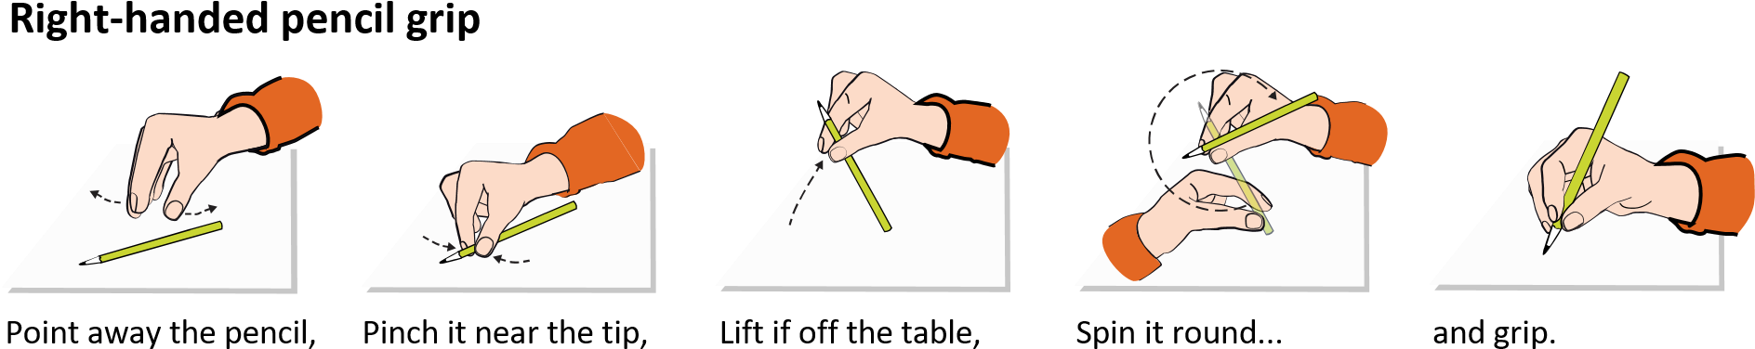

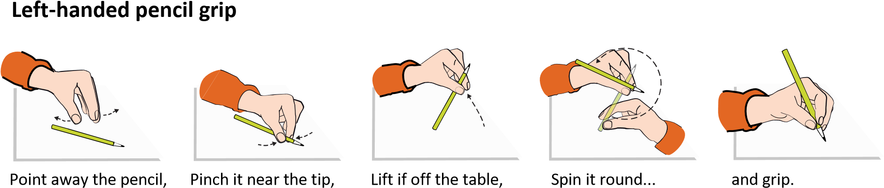

Phase Expectations for Handwriting

Early Years
By the end of the EYFS, all children should be able to recognise and form correctly all printed uppercase and lowercase letters of the alphabet from the correct starting points so they are Year 1 ready.

For our youngest pupils we teach short handwriting lessons on a daily basis. Lessons will include;

- enhancing gross motor skills such as air-writing, pattern-making and physical activities
- exercises to develop fine motor skills such as mark-making on paper, whiteboards, sensory trays, iPads, tablets, etc.
- becoming familiar with printed letter shapes, their sounds, formation, and vocabulary linked to letter families
- correct sitting position and pencil grip for handwriting

Our handwriting expectations are in line DFE and EEF Guidance that states; ‘Accurate letter formation is an essential early skill that forms the basis of a fluent handwriting style. There is no quick way to develop these essential skills other than through regular and substantial practice.’
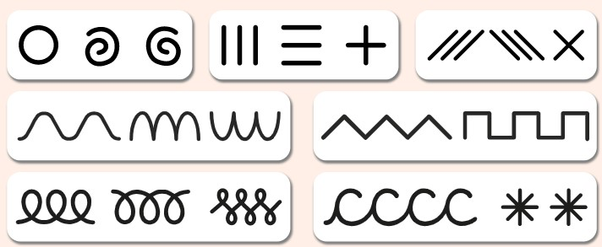
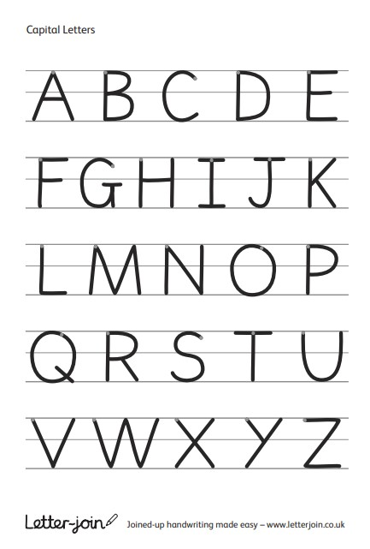

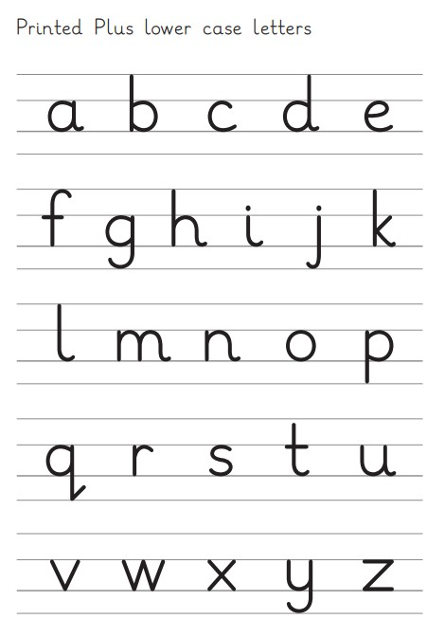

Links with Phonics

In the early stages of Reception, children will first develop their handwriting skills through pattern-making, pre-writing shapes, and fine motor activities that build the strength and control needed for letter formation. This focus ensures that pupils establish secure posture, pencil grip, and the motor patterns required before attempting full letter writing. While phonics teaching introduces children to letters and their sounds from the very start, handwriting lessons in the first term will concentrate on gross and fine motor preparation, directional movements, and simple shapes.

Children will typically encounter letters first in phonics sessions, and these experiences will be reinforced through separate, explicit handwriting teaching. By keeping handwriting and phonics distinct, children can internalise correct letter formation without the additional cognitive load of blending and segmenting. Over time, this approach secures both legibility and fluency in writing alongside accuracy in reading.

Key Stage 1: Years 1 and 2
Key Stage 1: Years 1 and 2 In Key Stage 1, we teach at least three discreet handwriting lessons per week, which build on children’s starting points to develop fully cursive joined up writing.

Lessons will include;
- continuing with gross and fine motor skills exercises
- learning cursive through letter families
- revisiting numerals, capitals and printed letters; where and when to use the lead in, learning and practice
- knowing high frequency words
- developing diagonal and horizontal joins which will support the spelling of Year 1 and 2 Statutory spellings and tricky words
- dictation exercises
- strengthening cursive handwriting, learning and practice
- Spelling, Punctuation and Grammar exercises
- Writing for non-statutory KS1 SATs

With the regular handwriting practice throughout Key stage 1, children will develop the fluency and speed of their writing to ensure it becomes automotive and that they have the stamina to achieve well in lessons and meet age related expectations.
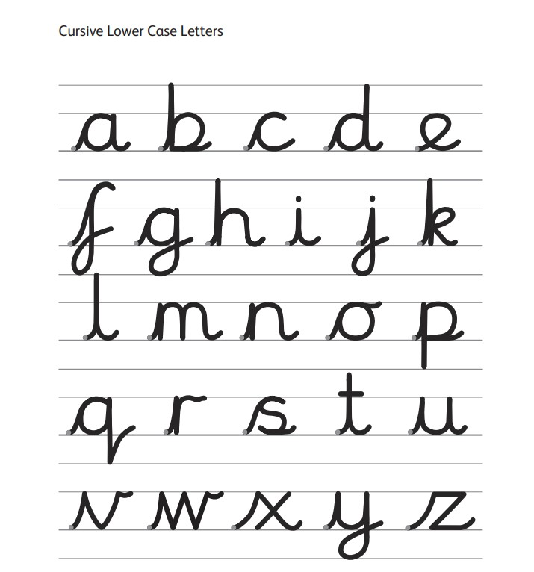

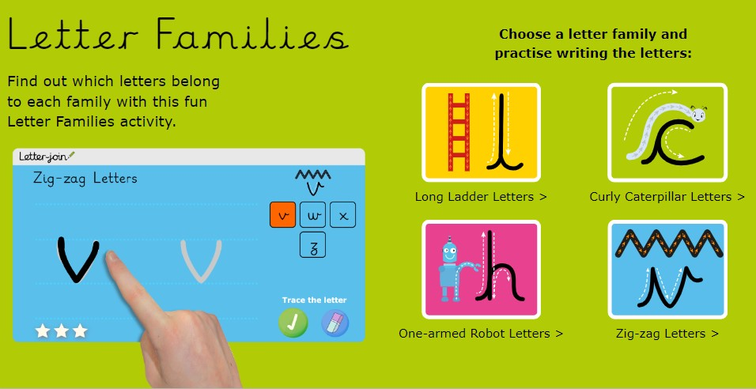

Key Stage 2:
Handwriting lessons will continue three times a week in Lower Key Stage 2 and only as needed in Year 5 and 6. Children should be using a cursive style throughout their independent writing in all subjects, helping to refine their handwriting in line with the requirements of each lesson. The focus of handwriting lessons will be to build fluency and consistency and will support other key areas of the curriculum for example statutory spellings and aspects of grammar and punctuation.

Lessons may include;
- exercises linked to spelling, grammar and punctuation for year group expectations
- reinforcement and practice of cursive handwriting joins
- dictation exercises promoting quick note-taking and speedy handwriting writing skills
- redrafting of writing for moderation
- KS2 SATs Spelling, Punctuation and Grammar practice

By the end of Key Stage 2 all children will have been given the opportunity to develop the stamina and skills to write at length in a given time frame, with accurate spelling and punctuation. They will be able to work towards producing consistently neat and well-presented handwriting in all curriculum subjects. Children should be producing cursive writing automatically, without thought, enabling them to focus on the content of their work rather than the process of writing so that they can achieve well in lessons and meet age related expectations for Year 6.

Capital Letters

Introduced from Reception if children are ready:

- In the Early Years the focus is on posture, grip, pre-writing patterns, and forming lowercase letters.

- Capital letters are introduced alongside lowercase (often when children learn to write their own name).

KS1

- Capital letters are explicitly covered with animations, worksheets, and online activities.

- Children are shown that capitals are always separate (unjoined) and larger than lowercase.

- Activities include labelling, filling in forms, and writing sentences with correct use of capitals and punctuation.

Letter-Join emphasises:

- Capitals should be taught as distinct shapes and never joined.

- Children should understand when to use them (e.g. names, start of sentences).

Using the Letter-Join Handwriting Recovery Programme

When to use the programme:

For pupils in upper KS2 who have not yet secured legible, fluent handwriting.

For children whose handwriting lacks automaticity, affecting their ability to focus on spelling and composition.

For pupils with specific motor difficulties or SEND, where extra scaffolded support is needed.

As a targeted intervention following handwriting assessment tracker results.

How to implement:

Begin with a teacher assessment to identify individual gaps (formation, joins, posture, grip, stamina).

Follow the step-by-step lesson plans provided in the programme, ensuring consistency with whole-school handwriting style.

Use targeted worksheets and online resources to reinforce lessons, both in small groups and at home where possible.

Provide frequent, short sessions (10-15 minutes) for maximum impact, separate from whole-class handwriting lessons.

Track progress using the Handwriting Assessment Tracker, adjusting support as pupils secure skills.

Key principles:

Focus on motor memory and automaticity before extended writing.

Ensure consistent modelling by adults of the agreed school handwriting style.

Use a multi-sensory approach

Celebrate small steps of progress to build confidence and motivation.

Handwriting at Home
Parents can support their children’s handwriting at home by using the Pupil log-in for Letter-join. Children can watch the word and letter animations and practice and explore other handwriting resources on Letter-join including;
- Magic Patterns
- Magic Words
- Phonics Match
- Word Search
- Word Bank
- Write it Right!

There are lots interactive and engaging activities for all year groups to support letter formation, cursive handwriting and spelling, grammar and punctuation.

Appendix

Year Group | Autumn Term | Spring Term | Summer Term | Expected Outcomes
EYFS (Reception) | Pencil grip, posture, pre-writing patterns, mark-making, air-writing.  Circles and Spirals  Lines and Diagonals  Jellies and Zig-zags  Loopies and Waves | Lowercase families:  i, l and t  u, w and e  c and o  a and d  n, m and h | Remaining lowercase letters, simple words  j and y  g and q  b, p and k  v, s and r  f, x and z | Secure tripod grip, form most lowercase letters correctly, begin writing words
Year 1 | Review grip. Warm-ups, Letter Families and Capital Letters.  Printed Letters. | All lowercase cursive letters, some diagonal joins | Full range of joins, introduce capitals and numbers | Consistent cursive, begin joining, spacing awareness
Year 2 | Consolidate capitals, numbers, joins | Introduce complex joins (horizontal, ascenders) | Dictations, high-frequency words, SATs prep handwriting | Joined writing across curriculum, speed & fluency developing
Year 3 | Reinforce joined handwriting, consistency | Dictations, spelling patterns, vocabulary | Cross-curricular writing | Legible, fluent joined handwriting across subjects
Year 4 | Fluent joined writing in cross-curricular tasks | Vocabulary practice, dictations, SPaG, MFL integration | Extended writing with stamina and neatness | Fluent, clear handwriting across curriculum
Year 5 | Consolidate fluency & stamina, accuracy in spelling/punctuation | Write at length across curriculum, automatic cursive | Adapt style for different tasks (drafts vs final work) | Automatic handwriting, stamina for extended writing
Year 6 | SATs prep: fluency, stamina, accuracy | Personal style, speed writing vs neat work | Consolidation: adapt style (notes, polished text, capitals) | Confident, automatic cursive, adaptable for purpose

*Teachers may wish to progress more rapidly if they feel the class are ready.

Phase Expectations for Handwriting

Reception: Write recognisable letters, most of which are correctly formed

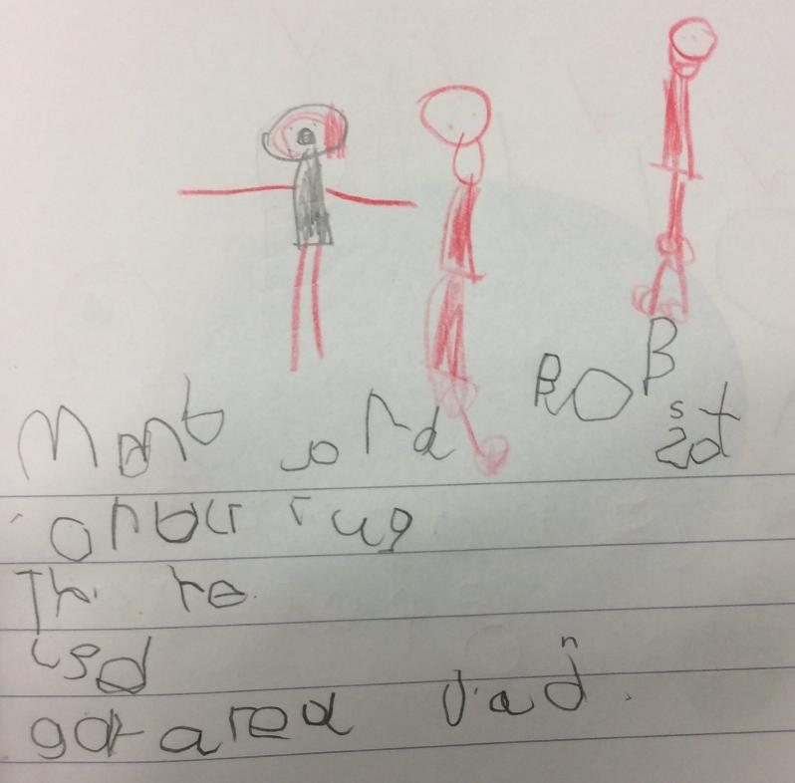

Year 1: Separate words with spaces

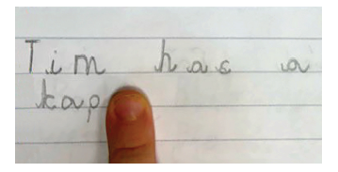

Year 2: Correctly-sized lowercase letters/starting to join/word spacing/ capitals and digits

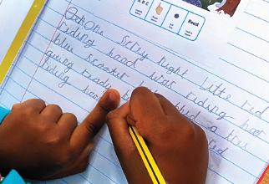

Year 3: Consistent joining, letter size and spacing

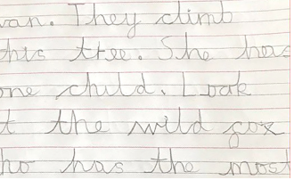

Year 4: Write fluently using correct joins, ascenders and descenders

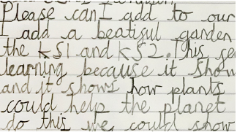

Years 5 and 6: Maintain legibility and fluency in joined handwriting when writing at speed
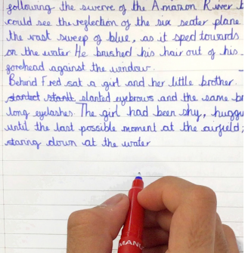

Handwriting: Do’s and Don’ts (DfE Writing Framework 2025)

✅ Do’s
- Teach handwriting daily in short, explicit lessons (10-15 mins in Reception/Year 1).
- Model correct letter formation every time-including grip, posture, and paper position.
- Use lined paper or books so children learn how letters sit on the line and the relative size of tall/short/tail letters.
- Reinforce good grip and posture:
  - BBC = Bottom/back/chair
  - TNT = Tummy near table
- Build automaticity through repeated correct practice until writing becomes fluent and effortless.
❌ Don’ts
- Don’t use dot-to-dot or dotted letters-children copy the dots rather than learn the letter’s motor pattern.
- Don’t rely on whiteboards- they encourage large, imprecise movements and don’t teach baseline awareness.
- Don’t leave handwriting to “incidental correction” during writing activities- it must be explicitly taught.
- Don’t allow poor grip, posture, or starting points to continue uncorrected.
- Don’t overload children with too much composition before handwriting is automatic.

Raising the Profile of Handwriting

Key Message
The most powerful motivator is authentic purpose and recognition. When pupils see their handwriting used, celebrated, and admired beyond worksheets -in letters, displays, and community projects-they invest more care and attention, which naturally supports fluency.

Classroom-based Activities
- Handwriting Challenges: timed but calm dictations, “copy and improve” exercises, or fluency races where pupils aim for neatness and speed.
- Golden Pen Awards: certificates, stickers, or special “handwriting pens” for pupils who show improvement or consistent care.
- Handwriting Heroes Wall: display exemplary pieces weekly, with names of children who showed pride in presentation.
- Mystery Writer: anonymise and display a beautifully written piece from the class — pupils guess whose writing it is.
- Copywork with Purpose: using poetry, famous quotes, or favourite story excerpts to practise fluency instead of random sentences.

Whole-School Engagement
- Handwriting Week / Focus Days: themed events where pupils write invitations, poems, or letters by hand for a real audience (parents, community, partner schools).
- Letter Writing Projects: link to curriculum topics e.g. writing to authors, local councillors, or pen pals. Purpose makes neatness matter.
- Handwriting Exhibition: showcase the best examples across year groups at parent evenings or assemblies.
- Staff Modelling Campaign: all adults in school commit to modelling neat, cursive handwriting on displays, feedback, and whiteboards.

Creative & Cross-Curricular Links
- Calligraphy / Decorative Writing: for pupils, using special pens, ink, or chalk to inspire pride and precision.
- Art & Handwriting Fusion: integrate handwriting into art projects — e.g. illuminated letters, illustrated poems.
- Curriculum Links: science notebooks, geography fieldwork journals, or RE reflections written with particular care. Show children that handwriting has value beyond English.

Motivation & Self-Improvement
- Personal Handwriting Goals: each pupil sets a half-term goal (e.g. “keep all tall letters the same size” or “improve speed without losing neatness”).
- Before & After Portfolios: keep samples each term so children can see visible progress.
- Peer Praise: partners highlight one thing their classmate has improved in handwriting.

