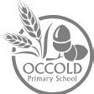

Early Reading at OccoldPrimary School.
At Occold, our approach to early reading is firmly based on systematic synthetic phonics.
What is Phonics?
Phonics is a way of teaching children how to read and write. It helps children hear, identify and use different sounds that distinguish one word from another in the English language. Written language can be compared to a code, so knowing the sounds of individual letters and how those letters sound when they’re combined will help children decode words as they read. Understanding phonics will also help children know which letters to use when they are writing words. Phonics involves matching the sounds of spoken English with individual letters or groups of letters. For example, the sound k can be spelled as c, k, ck or ch. Teaching children to blend the sounds of letters together helps them decode unfamiliar or unknown words by sounding them out. For example, when a child is taught the sounds for the letters t, p, a and s, they can start to build up the words: “tap”, “taps”, “pat”, “pats” and “sat”.

Why do we use carefully matched books?
When children learn to read, it is important our children are provided with phonetically decodable books because it allows them to apply their knowledge of letters and sounds. Because the child can decode every word in the book, they feel successful, which in turn helps them build fluency and develop good reading strategies. If the child reads a text that is NOT decodable (contains sounds they have not yet learned) the child is unable to use the skills, they have learnt and often they resort to incorrect strategies that lead to reading difficulties - children can become frustrated and begin guessing at words. They lose the direct connection between phonics and the text they are reading. To become a proficient reader, children must develop and practice applying their knowledge of letters and sounds. Decodable texts provide the child with material they have the skills to decode correctly. Decodable texts help children build necessary skills.

How is the teaching of phonics supported at Occold?
Like many schools, our approach to the teaching of phonics has been based on the ‘Letters and Sounds’ programme. We have a rich resource of books that provide children with reading books that are closely aligned to the phase and the phoneme set being taught. These highly decodable books encourage children to practice and apply their decoding skills. Recently, we have been following Ofsted’s phonics evaluation

programme and are in the process of strengthening our teaching of phonics through the newly validated Bug Club programme from Pearson.

Bug Club Phonics
This book is focussed on the /c/ sound made by the phonemes k, ck and ch This BugClub books are closely aligned to each phase and set within.
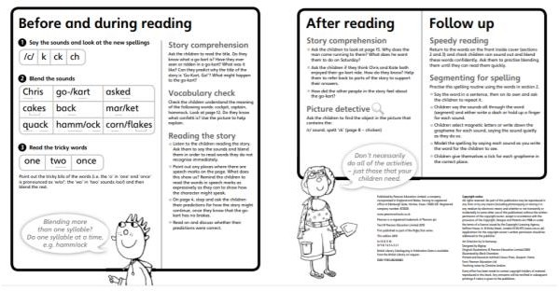
This Bug Club books are closely aligned to each phase and set within.
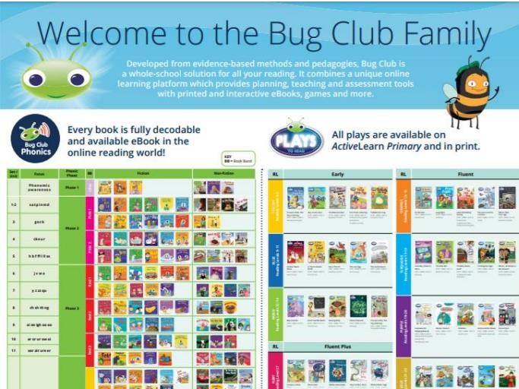

Next steps.
We understand that it is crucial to avoid reading being reduced only to phonics, no matter its importance. After all, we wouldn’t want our children to miss an encounter with the Gruffolo because the book isn’t decodable. Children should also have many opportunities to read and enjoy books for pleasure, outside of phonic lessons and the reading scheme. This is why we have high quality books, chosen to inspire reading for pleasure and to develop cultural capital. Each year, these are revised to include children’s recommendations and new releases. To avoid confusion, if these are taken home, they are labelled so that are to be shared or to be read out by the adult.

