

SEND Information Report

Date: | 27th July 2025
Chair of Governors: | Carol Peters
Review Frequency (Years): | 1
Date of Next Review: | July 2026

Written by Miss Lianne Walsh – SENDCo

Contents

1. Aims……………………………………………………………………………………………………2 2. Legislation and guidance ....................................................................................................... 2 3. Definitions .............................................................................................................................. 3 4. Roles and responsibilities ...................................................................................................... 3 5. SEND information report ........................................................................................................ 5 6. Monitoring arrangements ..................................................................................................... 14 7. Links with other policies and documents .............................................................................14

……………………………………………………………………………………………………………….

- Aims
Our SEND policy and information report aims:
At Occold Primary School we recognise each pupil as an individual. We seek to equip each pupil with the knowledge, skills and understanding necessary to reach their full potential and to become responsible, caring citizens in the future.

The majority of pupils will progress within the normal planned arrangements for a balanced curriculum, but when a pupil is identified as having SEND, we as a school will ensure special educational provision is put into place to support their learning. Special educational provision is provision that is additional to or different from the curriculum offer. It is a balance of teacher adjustments, support/resources and interventions.

In accordance with the Special Educational Needs and Disability Code of Practice 2014,
we aim to:

- address the requirements of those pupils with Special Educational Needs using the graduated approach of the 4-part cycle: assess, plan, do, review. We achieve this with our digital graduated approach forms which teachers/SENDCO use together to monitor and address children’s needs.
- provide a safe, happy and caring learning environment that meets the needs of each pupil.
- ensure all staff have high expectations of all pupils and teach in a way that makes learning enjoyable and challenging and allows all pupils to experience success.
- help the pupils to respect and value themselves and others.
- meet each pupil’s individual needs and ensure all pupils have access to a broad and balanced curriculum.
- involve all parents, staff and pupils in the decision and learning process, acknowledging and drawing upon parent knowledge and expertise in relation to their child.
- ensure all staff are aware of their roles and responsibilities in identifying and meeting the needs of SEND pupils and have accessed suitable training.

In the Special Educational Needs and Disability Code of Practice 2014 the four categories are as stated:

o Communication and Interaction
o Cognition and learning
o Social, emotional and mental health difficulties
o Sensory and/or physical needs

- Legislation and guidance
This policy and information report is based on the statutory SEND code of practice: 0 to 25 years - GOV.UK and the following legislation:

- Part 3 of the Children and Families Act 2014 which sets out schools’ responsibilities for pupils with SEN and disabilities.
- The Special Educational Needs and Disability Regulations 2014, which set out schools’ responsibilities for education, health and care (EHC) plans, SEND co-ordinators (SENDCos) and the SEND information report.

- Definitions
A pupil has SEND if they have a learning difficulty or disability which calls for special educational provision to be made for them.

They have a learning difficulty or disability if they have:

- A significantly greater difficulty in learning than the majority of others of the same age, or
- A disability which prevents or hinders them from making use of facilities of a kind generally provided for others of the same age in mainstream schools.

Special educational provision is provision that is additional to or different from the curriculum offer. It is a balance of teacher adjustments, support/resources and interventions.

4. Roles and responsibilities
4.1 The SENDCo

The SENDCo is Miss Lianne Walsh (sendco@occoldprimary.org.uk)
They will:

- Ensure the setting is inclusive. They must, with help from the senior leadership team, lead the school community in adopting inclusive values and practice.
- Work with the Head of School/Executive Headteacher and SEND governor to determine the strategic development of the SEND policy and provision in the school.
- Have day-to-day responsibility for the operation of the SEND policy and the co-ordination of specific provision made to support individual pupils with SEND, including those who have EHC plans.
- Provide professional guidance to colleagues and work with staff, parents, and other agencies to ensure that pupils with Special Educational Needs receive appropriate support and high-quality teaching.
- Advise on the graduated approach to providing SEND support.
- Advise on the deployment of the school’s delegated budget and other resources to meet pupils’ needs effectively.
- Be the point of contact for external agencies, especially the local authority and its support services.
- Liaise with potential next providers of education to ensure pupils and their parents are informed about options and a smooth transition is planned.
- Work with the Head of School/Executive Headteacher and governing board to ensure that the school meets its responsibilities under the Equality Act 2010 with regard to reasonable adjustments and access arrangements.
- Ensure the school keeps the records of all pupils with SEND up to date.
- Support the identification of children with special educational needs and disabilities.
- Monitor the impact of provision in the setting.
- Liaise with other providers and outside agencies to seek additional support, where necessary.

4.2 The SEND governor

The SEND governor will:

- Help to raise awareness of SEND issues at governing board meetings.
- Monitor the quality and effectiveness of SEN and disability provision within the school and update the governing board on this.
- Work with the Head of School/Executive Headteacher and SENDCo to determine the strategic development of the SEND policy and provision in the school.

4.3 The Executive Headteacher

The Executive Headteacher will:

- Work with the Head of School, SENDCo and SEND governor to determine the strategic development of the SEND policy and provision in the school.
- Have overall responsibility for the provision and progress of learners with SEN and/or a disability.
- Ensure the setting is inclusive. They must, with help from the senior leadership team and SENDCO, lead the school community in adopting inclusive values and practice.

4.4 Class teachers

Each class teacher is responsible and accountable for:

- The progress and development of every pupil in their class, including where pupils access support from teaching assistants or specialist staff (CoP).
- Ensuring that high quality teaching, differentiated for individual pupils, is the first step in responding to pupils who may have SEND (CoP).
- Remain responsible for working with the child, on a daily basis. Where interventions or one-to-one teaching away from the main class, they should still retain responsibility for the pupil. (CoP).
- Working closely with any teaching assistants or specialist staff to plan and assess the impact of support and interventions and how they can be linked to classroom teaching.
- Working with the SENDCo to review each pupil’s progress and development and decide on any changes to provision.
- Ensuring they follow the SEND policy.
- Adapt teaching to respond to the strengths and needs of all pupils (TS5).
- Know when and how to differentiate appropriately, using approaches which enable pupils to be taught effectively (TS5).
- Having a secure understanding of how a range of factors can inhibit pupils’ ability to learn, and how best to overcome these (TS5).

- SEND Information Report
  - The kinds of Special Educational Needs that are provided for
Our school currently provides additional and/or different provision for a range of needs, including:
- Communication and interaction. For example, children with autistic spectrum disorder and speech and language difficulties.
- Cognition and learning. For example, dyslexia, dyspraxia, dyscalculia, dysgraphia and ADHD.
- Social, Emotional and Mental Health difficulties (SEMH). For example, anxiety disorders, depression, and obsessive-compulsive disorder.
- Sensory and/or physical needs. For example, visual impairments, hearing impairments, processing difficulties, and epilepsy.

  - Identifying pupils with SEND and assessing their needs
“The benefits of early identification are widely recognised – identifying need at the earliest point and then making effective provision improves long-term outcomes for the child or young person.” (DfES SEND Code of Practice 2014 – section 6.14).

We will assess each pupil’s current skills and levels of attainment on entry, which will build on previous settings and Key Stages, where appropriate. Class teachers will make regular assessments of progress for all pupils and identify those whose progress:

- Is significantly slower than that of their peers starting from the same baseline.
- Fails to match or better the child’s previous rate of progress.
- Fails to close the attainment gap between the child and their peers.
- Widens the attainment gap.

This may include progress in areas other than attainment, for example, social needs.

Slow progress and low attainment will not automatically mean a pupil is recorded as having a special educational need.
When deciding whether special educational provision is required, we will start with the desired outcomes, including the expected progress and attainment, and the views and the wishes of the pupil and their parents. We will use this to determine the support that is needed and whether we can provide it by adapting our core offer, or whether something different or additional is needed.

At Occold Primary School we have a clear approach to gathering evidence and identifying and responding to SEND. In identifying and assessing pupils with SEND the school has regard for the Code of Practice and employs strategies, which include:

- liaison with any feeder schools/playgroups.
- listening to the concerns from parents/carers.
- listening to the concerns from the pupils themselves.
- teacher assessments.
- advice received from external agencies.

  - Early Identification Flow Chart
Our Early Identification Flow Chart outlines our process for identifying pupils with SEND and assessing their needs. Attached is the Reception Flow Chart. We have separate charts for each Key Stage.

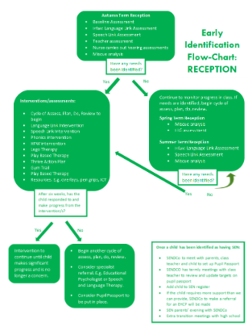

  - Graduated Approach
In line with this, teachers and the SENDCO use graduated approach forms which are a four-part continuous cycle which supports in identifying and meeting the needs of all children.

The cycle is made up of four stages:

1. Assess is identifying any barriers to learning that a child may be experiencing.
2. Plan is planning the changes you want to see.
3. Do is how the plan is going to be put into place.
4. Review is where you gather input from the people involved in the provision and evaluate whether it has been effective.

The SEND Code of Practice (2015) makes it clear that, “All teachers are responsible and accountable for the progress of all learners in their class, including where they access support from teaching assistants or specialist staff. This includes carrying out regular assessments of pupils’ progress to identify any pupils who are making less than expected progress.” This may be academic progress or progress of their wide development of social needs.

Our graduated approach form allows teachers and SENDCOs to clearly monitor any children whose progress we are concerned about and put arrangements in place to support them, where necessary. Attached is a blank form.

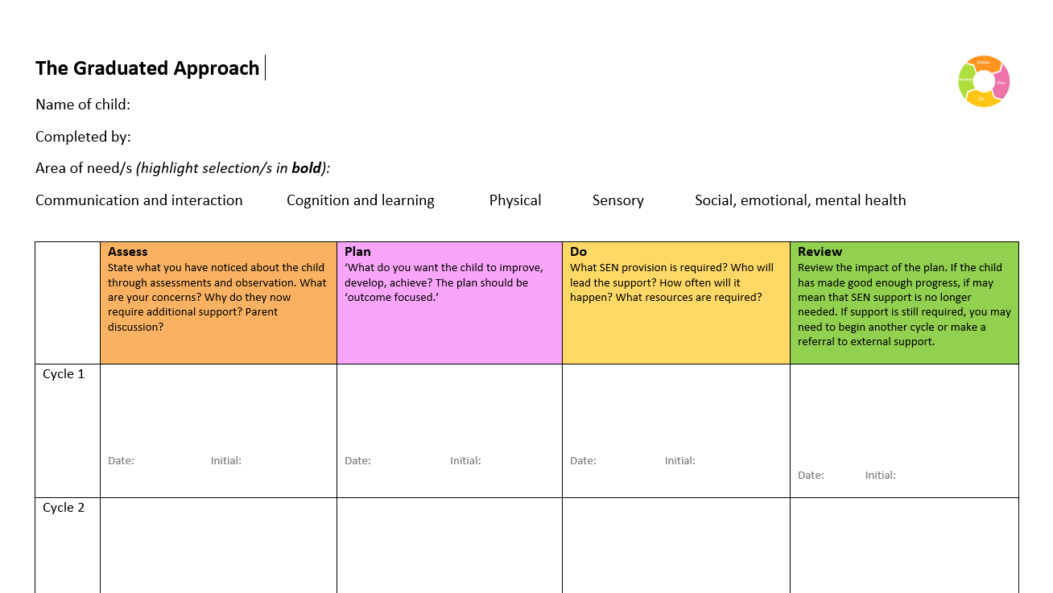

When a pupil has been identified as having a special educational need they are placed on the school’s SEND Register which is maintained by the SENDCo and copied to the Local Authority upon request. The class teacher and/or SENDCo will regularly meet with the parents/carers to discuss and explain the school’s concerns.

When a child is placed on the SEND register, they will also receive a Pupil Passport.

  - Pupil Passport
A Pupil Passport is a document for children with SEN which includes:

- key information about the child and a photograph of them.
- the child’s thoughts and preferences on their learning and needs.
- information for how best to support the child.
- termly targets for the child.
- progress towards each target.
Why do we have Pupil Passports?

- They paint a clear picture of the child and how best to support them.
- They allow everyone working with the child, and the child themselves, to understand the targets they are working on and the progress they are making.
- They help the child to become accountable for their own learning.
- The SEND Code of Practice states… “Where a pupil is receiving SEN support, schools should regularly set clear outcomes and review progress towards them,” “Schools should know precisely where children and young people with SEN are in their learning and development. They should have high ambitions and set stretching targets for them and track their progress towards these goals,” “Teachers should use appropriate assessment to set targets which are deliberately ambitious” and “Teachers are responsible and accountable for the progress and development of the pupils in their class, including those with SEN and/or where pupils access support from teaching assistants or specialist staff.” Attached is our Pupil Passport.

Attached is our Pupil Passport:

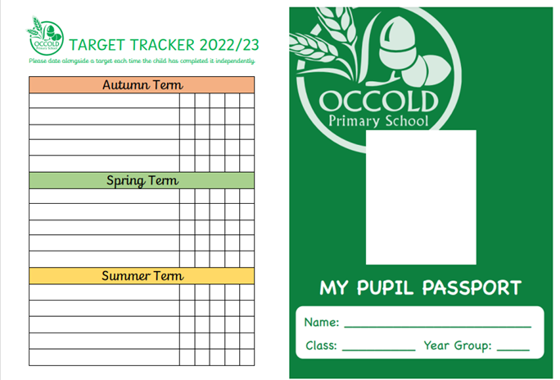
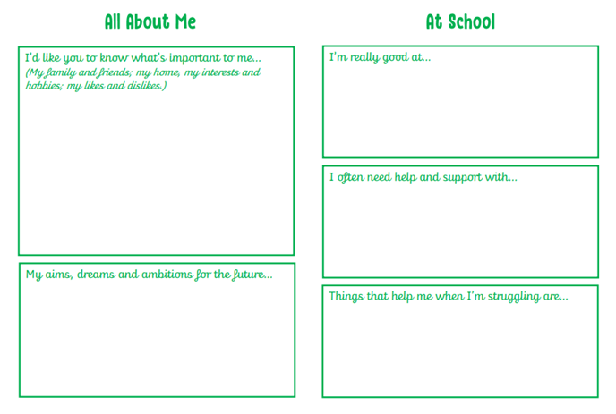
The triggers for SEND Support will be underpinned by evidence that the pupil, despite receiving differentiated learning opportunities makes little or no progress even when high quality teaching approaches are specifically targeted to the pupil’s area of weakness.

Where a pupil with Special Educational Needs continues to demonstrate significant cause for concern, despite the school meeting the needs of the pupil and providing relevant and purposeful support, the school or parents can consider requesting and Education, Health and Care Plan.

The local authority decides whether it is necessary for a pupil to have an EHC plan. The EHC plan will detail the pupil’s educational needs and the provision that the school will need to make in order to meet those needs. Key objectives will outline long term targets. The EHC plan will detail appropriate facilities and resources. The SENDCo has responsibility for pupils with EHC plans and will oversee the provision for these pupils within school and organise the Annual Review meeting.

When a pupil is receiving SEND support or has an Education and Health Care Plan, we as a school will meet with parents regularly to set targets and outcomes and review progress towards them. We will look at the activities and interventions that will help achieve the outcomes and provide opportunities for parents to share any concerns. The views of the pupils will also be gathered and discussed as part of the meeting.

These meetings will be vital in ensuring that everyone works together and agrees their aspirations for the pupil. A record of the information will be stored on a one-page pupil profile and within pupil passports and will be shared with appropriate school staff.

5.6 Consulting and involving pupils and parents

Parents/carers will be involved throughout, and their early involvement is of paramount importance. They will always be informed if the school identifies their child as having a special educational need.

When working with parents/carers we will focus on a pupil’s strengths as well as needs and draw on parental expertise and knowledge of their child. We adopt a positive attitude towards parents/carers, providing information to them in a user-friendly format. We recognise that some parents/carers themselves may have differing needs and take account of these in a sensitive manner. The class teacher will work closely with parents at all stages and should be the first port of call in case of difficulty. They can then be referred onto the SENDCo or Head of School/Executive Headteacher if necessary. The SENDCO will also offer parents’ evenings to parents of children on the SEND register.

We will have an early discussion with the pupil (if deemed appropriate) and their parents when identifying whether they need special educational provision. These conversations will make sure that:

- Everyone develops a good understanding of the pupil’s areas of strength and difficulty.
- We take into account the parents’ concerns.
- Everyone understands the agreed outcomes sought for the child.
- Everyone is clear on what the next steps are.

Notes of these early discussions will be added to the pupil’s record (SEND Timeline) and given to their parents. We will formally notify parents when it is decided that a pupil will receive SEN support or has been added to the SEND register.

  - Supporting pupils moving between phases and preparing for adulthood
We will share information with the school, college, or other setting the pupil is moving to. We will agree with parents and pupils which information will be shared as part of this.

When a child with SEND is transitioning to secondary school, the school will liaise closely with the receiving school to prepare the child for transition. Our SENDCO will always meet with the high school SENDCO to ensure transition is as smooth as possible. In addition to this, pupils will spend time in their new school, may have additional transition days, may receive a transition passport and will meet their high school SENDCO.

  - Our approach to teaching pupils with SEN (Including SEND Provision)

All teachers are teachers of pupils with SEND and adapt the curriculum to meet their need. Class teachers will identify pupils with any possible special educational need and bring these to the attention of the SENDCo/ Head of School/Executive Headteacher using the graduated approach.
Teachers are responsible and accountable for the progress and development of all the pupils in their class.

High quality teaching is our first step in responding to pupils who have SEND. This will be differentiated for individual pupils.

Some children may require special educational provision. Special educational provision is provision that is additional to or different from the curriculum offer. It is a balance of teacher adjustments, support/resources and interventions.

Teacher adjustments
Teacher adjustments refer to the ‘tweaks’ that staff make when teaching to enable greater access and participation for learners. For example, when a teacher or teaching assistant knows that a learner experiences reading as a barrier, then they may read to the learner rather than asking them to read the text themselves. Similarly, if they know that a learner has a small working memory, they will reduce the amount of information the learner is required to hold and may provide them with a resource which summarises the taught information. Examples include: step by step instructions, visual prompts, now and next, advanced warning of change, seating at the front, short ‘bursts’ of work, pause to ask questions.

Support/resources
Support is when the learner is provided with additional support from an adult or a peer. It may be using an adult to scribe for a child or using peer support to access the learning together. Resources are physical resources that are used to support the learning. This could include pencil grips, technology to type, fidget toys, sensory cushions, weighted blanket, ear defenders, voice recorders, personalised reward chart, visual timetable and now and next board.

Interventions
An intervention is ‘an action with a positive intent.’ This could be a purchased intervention such as Little Wandle Rapid Catch Up, Power of 2 or Language Link. It could also be individual, or group sessions based on certain area of learning e.g. working memory activities, active listening games, sensory circuits, jewellery making.

Children’s SEND provision are highlighted in their personalised provision plans. See attached.

.

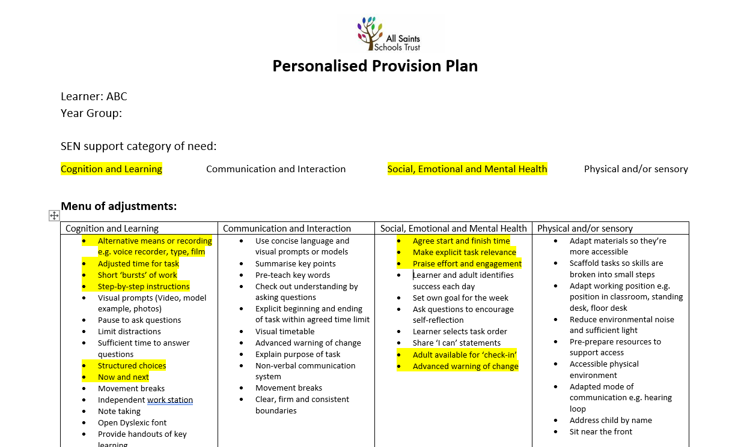

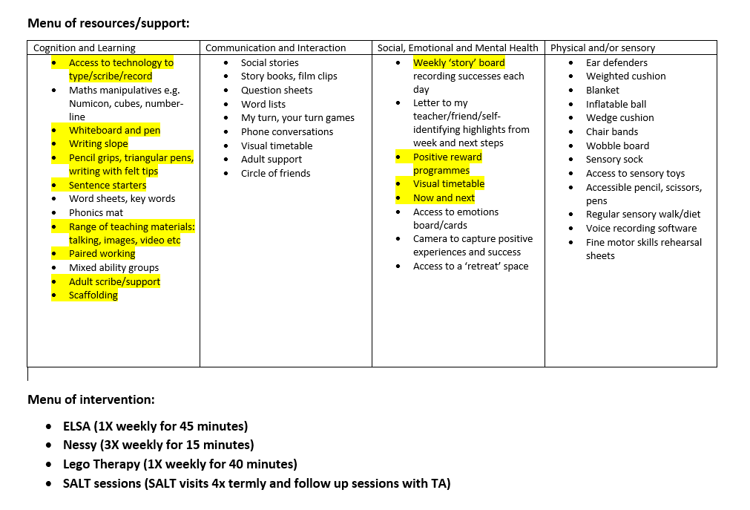

All teachers who have children working in their class working towards the pre-key stage standards have had up-to-date training from the SENDCO to ensure they’re confident in completing the necessary assessments. All teachers and 1:1 support staff who have children working in their class working towards the Engagement Model have attended Engagement Model training led by SES. Our Engagement Model plans, scrapbooks and assessment tools have been reviewed by the cognition and learning leader of SES who has stated we have ‘exemplary practice’ in place.

  - Additional support for learning
Subject to funding available, the school will endeavor to provide a full time Teaching Assistant in every class. Children may be supported by Learning Support Assistants, who are usually employed to work with specific children either 1:1 or in small groups and funded by High Needs Funding.

‘The role of the teaching assistant is to support teachers so that they can provide high quality teaching to those who need it the most, when they need it the most.’
(Maximizing the Impact of Teaching Assistants (Webster et al 2021).

We work with a range of following agencies to provide support for pupils with SEND, including:

- SES (Specialist Education Services)
- Education Psychologists
- Speech and Language Therapists
- Occupational Therapists
- School Nurse
- Primary Mental Health Workers

5.10 Expertise and training of staff

Miss Lianne Walsh is currently completing her NPQ in SEN.
Miss Lianne Walsh works one day a week for the school to complete her SENDCO role.
Mrs Gemma Watts is the Executive Headteacher at Occold and uses her expertise in SEND to support the school’s SENDCO.
The All Saints Schools Trust CEO (Mrs Melanie Barrow) is experienced in SEND.

5.11 Securing equipment and facilities

The school will provide equipment to support pupils with SEND, depending on the need. Alternative and/or additional funding may be required for certain items.

The school receives money through the overall budget, the Executive Headteacher, SENDCo and governing body will then decide how to allocate the resources to support the progress of pupils with SEND. Where a pupil’s provision exceeds that of the nationally prescribed threshold, additional funding (High Needs Funding) from the Local Authority can be applied for by the school.

If a child receives an EHC plan a parent has the right to request a personal budget from the Local Authority. A personal budget is an amount of money identified by the local authority to deliver provision set out in the EHC plan.

5.12 Evaluating the effectiveness of SEND provision
We evaluate the effectiveness of provision for pupils with SEND by:

- Reviewing pupils’ individual progress towards their goals each term.
- Reviewing the impact of interventions after a set number of weeks.
- Using pupil questionnaires.
- Monitoring by the SENCO.
- Using provision maps.
- Holding Annual Reviews for pupils with EHC plans

5.13 Enabling pupils with SEND to engage in activities available to those in the school who do not have SEND

All of our extra-curricular activities and school visits are available to all our pupils, including our before-and after-school clubs.
All pupils are encouraged to go on our residential trip(s) in Year 6.
All pupils are encouraged to take part in sports day/school plays/special workshops, etc.
All pupils in KS2 go swimming weekly and additional needs are catered for.
UKS2 pupils learn to play a musical instrument, and additional needs are catered for.
No pupil is ever excluded from taking part in these activities because of their SEN or disability.

5.14 Support for improving emotional and social development

We provide support for pupils to improve their emotional and social development in the following ways:

- Pupils with SEND are encouraged to be part of the school community.
- Pupils with SEND may be part of a nurture group to promote teamwork/building friendships etc.
- We have a qualified ELSA who leads sessions with children in need of support for their emotional development.
- We have a qualified Lego Therapist who leads sessions which children in need of support for their social development.
- We use the Stirling Wellbeing Assessment twice annually to monitor the children’s wellbeing. We then use these results to ensure that any children who display concerns with their wellbeing have provision in place to support them.
- The Zones of Regulation is embedded across the school to help support children’s emotional wellbeing.
- All classrooms have a Zones of Regulation display in.
- We have a zero-tolerance approach to bullying.
5.15 Working with other agencies

The school involves other bodies, including health and social care bodies, local authority support services and voluntary sector organisations, in meeting pupils' SEND and supporting their families.

5.16 Complaints about SEND provision

Wherever possible, staff will work with parents/carers to make sure that any disagreements or complaints are resolved without recourse to the formal complaints’ procedure. When an issue of complaint or disagreement does arise, parents should make their complaint known to the SENDCo in the first instance and if needed, seek further information detailed in the Complaints Procedure.
The parents of pupils with disabilities have the right to make disability discrimination claims to the first tier SEND tribunal if they believe that our school has discriminated against their children. They can make a claim about alleged discrimination regarding:

- Exclusions
- Provision of education and associated services
- Making reasonable adjustments, including the provision of auxiliary aids and services

5.17 Contact details for raising concerns

If parents/carers have concerns about their child, then they should contact the SENDCo at the school. The SENDCO can be contacted here: sendco@occoldprimary.org.uk

5.18 The local authority local offer
Our contribution to the local offer is available on the school website:
https:Occold Primary School - Home
Our local authority’s local offer is published on the school website.

- Monitoring arrangements
This policy and information report will be reviewed by the SENDCO and governing body every year. It will also be updated and approved by the governing board.

- Ling with other policies and documents
This policy links to our policies on:

- SEND policy
- Behaviour
- Accessibility plan
- Equality information and objectives
- Supporting pupils with medical conditions

