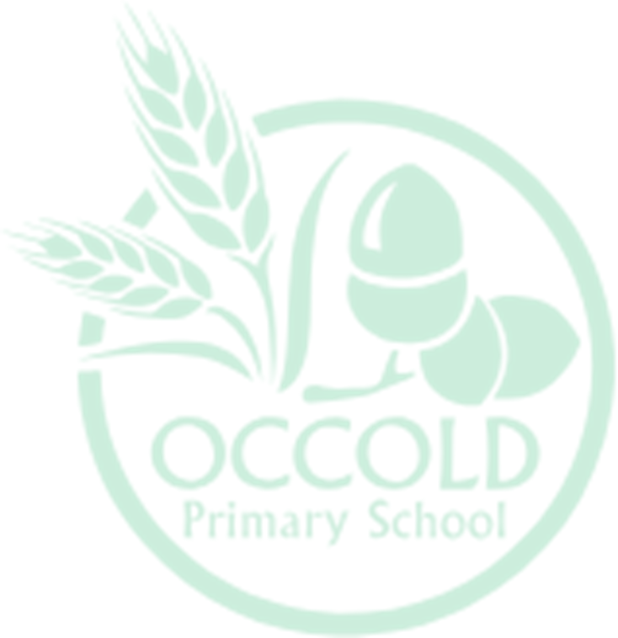
2025/2026
 | Week 1 | Week 2 | Week 3 | Week 4 | Week 5 | Week 6 | Week 7 | Week 8 | Week 9 | Week 10 | Week 11 | Week 12
Autumn  Amazing Oceans | Recount | Naughty Bus  Writing Outcomes:  Shared Journal  Speech/Thought Bubbles  Song writing  Caption Writing  Own and Class Books |  |  |  | Pattan’s Pumpkin  Writing Outcomes:  Information Writing  Captions, Labels and Posters  Free Verse Poetry  Letter Writing  Thought Bubbles  News Report  Song Writing – Lullabies  Writing in Role: Diary  Story Telling  Narrative: Myths |  | Beegu  Writing in role  Free verse poetry  Instructional writing  Letter Writing |  |  |  | NFER assessments
Spring  Transport  Africa | Recount | The Last Wolf  Writing Outcomes:  Oral Storytelling  Speech and Thought Bubbles  Poetry  Information Writing  Persuasive Speech  Writing in Role  Advisory Note  Letter  Free Writing |  |  |  | The Jolly Postman  Writing Outcomes:  Story mapping  Story Boxes  Shared Writing  Bookmaking  Writing in Role  Letters |  |  |  | 10 Things I can do to help my world  Writing Outcomes:  Shared Reading Journal  ‘Tell Me’responses  Labels and captions for recycling displays and areas  Conservation posters  Letter to the headteacher  Caption writing  Call and response poem  Information Writing  Bookmaking |  | NFER assessments
Summer  Transport – Amelia Earhart  Castles | Recount | The Dark  Description of the dark  Writing a narrative sequence retelling the story  A free-verse poem about the dark (or light)  Piece of advice for Lazlo  Call and response poetry to reassure fears  Non-chronological report about nocturnal animals  Book review |  |  |  |  | Traction Man  Writing in Role  Caption Writing  Letter Writing  Narrative Writing |  |  |  |  | NFER assessments

